Multiple-choice section

Question 1 [4.1]

The missing number in the equation 0.71 = is:

|  |  |  |  |  |
| --- | --- | --- | --- | --- |
| Ones | . | Tenths | Hundredths | Thousandths |
| 1 | . |  |  |  |
|  | . |  |  |  |

A 7.1 B 1 C 71 D 7

Question 2 [4.1]



The arrow points to the number:

A 0.6 B 1.06 C 1.16 D 1.6

Question 3 [4.2]

5.376 rounded to 2 decimal places is:

A 5.3 B 5.4 C 5.37 D 5.38

Question 4 [4.3]

5.2 as a fraction in simplest form is:

A $\frac{5}{25}$ B $5\frac{25}{10}$ C $5\frac{1}{4}$ D $5\frac{2}{5}$

Question 5 [4.5]

Calculate: 2.4 × 3

A 7.2 B 6.12 C 5.4 D 61.2

Question 6 [4.7]

Write $\frac{2}{5}$ as a percentage.

A 40% B 0.25% C 2.5% D 50%

Question 7 [4.7]

0.46 written as a percentage is:

A $\frac{46}{100}$ B 46% C 4.6% D $\frac{23}{50}$

Question 8 [4.8]

10% of $40 is:

A $4.00 B $0.40 C $2.00 D $0.20

Question 9 [4.8]

Ang has collected 5 of the 20 figures in a set. What percentage does he have?

A 5.2% B 2.5% C 25% D 75%

Question 10 [4.9]

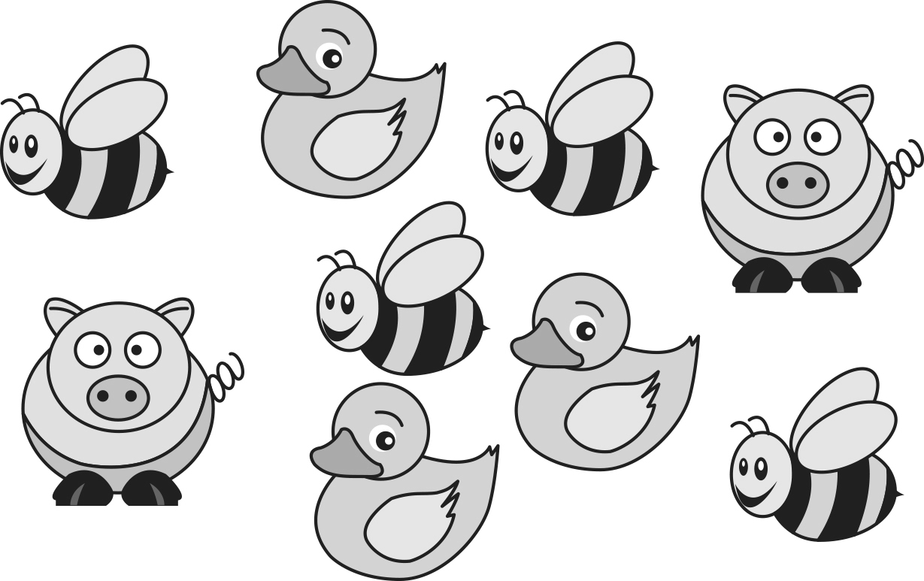

The ratio of ducks to bees is:

A 4 : 3 B 3 : 9 C 3 : 2 D 3 : 4

Multiple-choice total marks: \_\_\_\_ / 10

Short answer section

Question 11 3 marks [4.3, 4.9]

Use words from the list below to complete the following sentences

*add divide multiply recurring ratio subtract rate terminating*

(a) To write a fraction as a decimal you \_\_\_\_\_\_\_\_\_\_\_\_\_\_\_\_\_\_ the numerator by the denominator.

(b) A \_\_\_\_\_\_\_\_\_\_\_\_\_\_ decimal is one that has a repeating pattern of digits.

(c) A \_\_\_\_\_\_\_\_\_\_\_\_\_\_ is a comparison of two or more quantities using a ‘:’ symbol.

Question 12 3 marks [4.1]

On the number line below, draw arrows to show the position of:

(a) 3.2 (b) 3.14 (c) 3.03

Macintosh HD:Users:lizwaud:Desktop:PM7_eBook:Batch 1 commenced:Artwork_CORRECTED_041016_Use this:Ch4:PM2e_07_EB_04_FAT_03.jpg

Question 13 2 marks [4.1]

Write the following as decimals.

(a)  (b) 

$\frac{3}{10}+\frac{1}{100}+\frac{5}{1000}$

Question 14 2 marks [4.1]

Write the following in order from smallest to largest.

(a) 3.21, 3.12, 3.021

(b) 0.05074, 0.0574, 0.00574

Question 15 1 mark [4.1]

Using the table, write 2 units, 3 hundredths and 6 thousandths in decimal form.

|  |  |  |  |  |
| --- | --- | --- | --- | --- |
| Ones | . | Tenths | Hundredths | Thousandths |
| 1 | . |  |  |  |
|  | . |  |  |  |

Question 16 3 marks [4.2]

Which of the two numbers in brackets is the given number closer to?

|  |  |  |
| --- | --- | --- |
| (a) 12.734 (12.7 or 12.8) | (b) 0.3481 (0.34 or 0.35) | (c) 1.095 (1.09 or 1.1) |

Question 17 3 marks [4.2]

Round the following to the number of decimal places shown in brackets.

|  |  |  |
| --- | --- | --- |
| (a) 45.657 (2) | (b) 1.3758 (3) | (c) 34.437 (1) |

Question 18 2 marks [4.4]

Calculate the following.

|  |  |
| --- | --- |
| (a) 2.4 + 6.32 | (b) 6 + 0.7 + 1.25 |
|  |  |

Question 19 2 marks [4.4]

Calculate the following.

|  |  |
| --- | --- |
| (a) 1.365 – 0.234 | (b) 23.4 – 6.75 $2 3 .4 -$ |

Question 20 3 marks [4.5]

Calculate the following.

|  |  |  |
| --- | --- | --- |
| (a) 35.78 × 100 | (b) 0.7634 × 1000 | (c) 4.1 × 5 |

Question 21 2 marks [4.5]

Calculate the following.

|  |  |
| --- | --- |
| (a) 2.5 × 300  = 2.5 × 3 × \_\_\_\_\_\_\_\_\_\_  = \_\_\_\_\_\_\_\_\_ × 100  = \_\_\_\_\_\_\_\_\_ | (b) 0.4 × 0.7  (4 × 7 = \_\_\_\_\_\_\_)  0.4 × 0.7 = \_\_\_\_\_\_\_\_\_ |

Question 22 3 marks [4.6]

Calculate the following.

|  |  |  |
| --- | --- | --- |
| (a) 36.63 ÷ 10 = \_\_\_\_\_\_\_\_\_\_\_ | (b) 7.09 ÷ 100 = \_\_\_\_\_\_\_\_\_\_\_ | (c) 23.2 ÷ 4 = \_\_\_\_\_\_\_\_\_\_\_ |

Question 23 6 marks [4.7]

Complete the table.

|  |  |  |
| --- | --- | --- |
| Fraction (simplest form) | Decimal | Percentage |
|  | 0.1 |  |
|  |  |  |
|  |  | 25% |
|  |  | 20% |
|  | 0.75 |  |
|  |  |  |
|  | 0.333… |  |

Question 24 2 marks [4.8]

|  |  |
| --- | --- |
| (a) Find 10% $\%$ of 140. | (b) Find 5% $5\%$ of 160. |

Question 25 2 marks [4.8]

Marco received 16 marks out of 40 in his spelling test. What percentage was this?

(Hint: Write it as a fraction first, then multiply by 100.)

Question 26 4 marks [4.9]

Complete the equivalent ratios.

|  |  |
| --- | --- |
| (a) 3 : 5  = 12 : \_\_\_  = \_\_\_ : 10 | (b) 1 : 5 : 7  = 3 : \_\_\_\_ : \_\_\_\_ |

Short answer total: \_\_\_\_\_\_\_\_\_ / 43

Extended answer section

Question 27 7 marks [4.1, 4.4, 4.6]

(a) Draw a number line starting at 0 and finishing at 2 with ten intervals between the numbers.

(b) Mark the positions of these decimals on your number line:

(i) 0.3 (ii) 0.9 (iii) 1.3 (iv) 1.9

(c) The interval between 0.5 and 0.6 has been magnified as shown below.  
What number does point A represent?

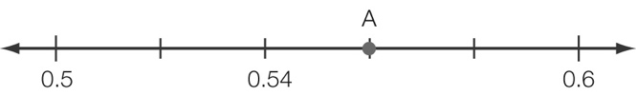

(d) What is the value of the decimal that is halfway between 0.6 and 1.8? You may use your first number line above to help you answer this.

Question 28 6 marks [4.4, 4.8, 4.9]

(a) Anita is a 100 m hurdler. In her last three races, her times have been 16.34 seconds, 16.06 seconds and 16.19 seconds. If her fourth race was 0.12 seconds faster than her fastest time, what was her time for the race? (Remember: the fastest time is the smallest number.)

(b) What is the difference between Anita’s fastest and slowest times in the four races?

(c) As part of her training Anita, needs to eat 10 200 kilojoules daily, which is broken up into five serves. She is to have two serves for breakfast, two serves for lunch and one serve for dinner.

(i) How many kilojoules are in one serve?

(ii) How many kilojoules does she have at breakfast?

(d) What is the ratio of Anita’s breakfast intake to her lunch intake? Write your answer in simplest form.

(e) On days when Anita does not train she has only 70% of her daily kilojoule intake. What is her daily kilojoule intake on these days?

Extended answer total: \_\_\_\_\_\_\_\_\_ / 13

TOTAL test marks: \_\_\_\_\_\_\_ / 66